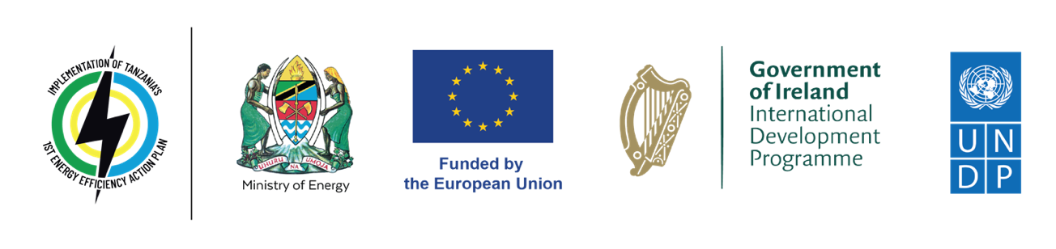

**Press Release** **Launch of 250 Million Tanzanian Shilling Energy Efficiency Innovation Challenge Unveils Path to Sustainable Energy Solutions**

**Dodoma, Tanzania - March 15, 2024** – Today marks the unveiling of the Energy Efficiency Innovation Challenge, a collaboration between the Ministry of Energy, the European Union (EU), the Embassy of Ireland, and the United Nations Development Programme (UNDP). This initiative, under the theme ***Igniting Sustainable Energy Practices for a Greener Future***, is backed by a substantial fund of 250 million Tanzanian shillings and is poised to strengthen the landscape of energy efficiency by fostering creativity and innovation.

Aligned with Tanzania’s Energy Efficiency Action Plan, this challenge endeavours to harness the ingenuity of Tanzanian innovators to confront the pressing challenge of energy efficiency. It aims to stimulate the development of ingenious solutions that not only mitigate unsustainable energy consumption but also uphold principles of sustainability and environmental stewardship.

To incentivise and support the brightest minds in Tanzania, innovators are invited to apply for one of the ten grants, each worth up to 25 million Tanzanian shillings, to further develop and implement their groundbreaking innovations. These grants aim to provide financial support backing and encouragement to those who demonstrate exceptional potential in shaping a more energy-efficient future for the nation. Furthermore, the 20 chosen finalists will participate in a one-week boot camp where they will receive coaching from energy experts to refine their ideas/projects. Following the event, the finalists will engage in a mentorship program for the duration of the project.

"Today, we embark on a journey of innovation and collaboration to address the critical need for energy efficiency in Tanzania. Through the Energy Efficiency Innovation Challenge, we aim to unlock the potential of Tanzanian innovators and drive transformative change in our energy landscape." – Commissioner for Electricity and Renewable Energy, Innocent Luoga, Ministry of Energy.

"The European Union is committed to supporting Tanzania's journey towards enhanced energy efficiency. The Innovation Challenge presents a remarkable opportunity to harness the potential of youth and women-led organizations, among others. We eagerly anticipate witnessing the ingenuity and creativity of Tanzanians as they contribute to sustainable energy solutions." – Cédric Merel, Head of Cooperation of the European Union Delegation to Tanzania.

“Ireland recognises the importance of energy efficiency in strengthening climate resilience, contributing to climate mitigation efforts and supporting the development sustainable livelihoods in Tanzania. We are delighted to support the Energy Efficiency Innovation Challenge to catalyse creativity and innovation, particularly from young women, to address specific energy efficiency challenges and promote sustainability.” Mary McCarthy, Deputy Head of Development, Embassy of Ireland.

"The launch of the Energy Efficiency Innovation Challenge represents a crucial step towards achieving our goal of a more sustainable energy future for Tanzania," said Aaron Cunningham, project manager at UNDP. "By empowering local innovators to develop cutting-edge energy-efficient technologies, we can drive positive change and create lasting impact in our communities."

Participants in the Energy Efficiency Innovation Challenge will have the chance to demonstrate their creativity and expertise in the realm of energy efficiency. Successful projects will not only receive financial support but also benefit from mentorship to refine their innovations and navigate the path to market. **Applications must be submitted by 5pm EAT on April 30th, 2024.**

To learn more about the Energy Efficiency Innovation Challenge and how to join, please visit: <https://www.energyefficiency.co.tz>. *follow us on social media (Instagram, LinkedIn, YouTube) @eetanzania*

Contact:

Jolson Masaki

Communications Analyst

United Nations Development Programme (UNDP)

[Jolson.masaki@undp.org](mailto:Jolson.masaki@undp.org)